

SUBMITTED TO:
SIR ASIF AHSAN
SUBMITTED BY:
HIFZA FAISAL (70135435)
FATIMA FAISAL (70135434)
IMAN FAISAL (70135459)
SECTION:
BSCS 7B
SUBJECT:
ARTIFICAL INTELLIGENCE

DOCUMENTATION

PROJECT:
IMAGE COLORIZATION

CHAPTER 1: INTRODUCTION

1.1 Background
Images play a very important role in communication and information sharing. However, many historical and old images are available only in grayscale (black and white). These images lack color information, which reduces their visual appeal and realism.
Image colorization is the process of converting grayscale images into colored images by automatically predicting the missing color information. With the advancement of Deep Learning and Computer Vision, it has become possible to train neural networks that learn color patterns from large datasets and apply them to grayscale images.
This project focuses on building an AI based image colorization system using Convolutional Neural Networks (CNN) and U Net architecture to convert grayscale images into realistic colored images.

1.2 Problem Statement
Manual image colorization is a time-consuming process and requires professional skills. Existing automatic methods often produce unrealistic or inaccurate colors.
The problem addressed in this project is:
How to automatically convert grayscale images into realistic colored images using deep learning techniques.

1.3 Objectives of the Project
The main objectives of this project are:
- To study image colorization using deep learning
- To preprocess grayscale and color data using LAB color space
- To design and train a CNN-based baseline model
- To design and train a U-Net based advanced model
- To compare CNN and U-Net performance
- To generate realistic colored images from grayscale inputs
- To visualize and evaluate results using graphs and images

1.4 Scope of the Project
This project focuses on image colorization using:
- LAB color space
- Deep learning models (CNN and U-Net)
- A large image dataset
- Quantitative and qualitative evaluation
The system can be extended for historical image restoration and real-time applications

CHAPTER 2: LITERATURE REVIEW

2.1 Image Colorization
Early image colorization methods used manual editing or rule-based techniques. These methods required human expertise and were not scalable.
Recent research shows that deep learning models, especially CNNs, can automatically learn color patterns from data and apply them to grayscale images.

2.2 Convolutional Neural Networks (CNN)
CNNs are widely used in computer vision tasks such as image classification, segmentation, and colorization. They extract spatial features from images using convolutional layers.
However, basic CNNs often fail to preserve fine details during colorization, resulting in limited or biased colors.

2.3 U-Net Architecture
U-Net is an encoder–decoder architecture with skip connections. It preserves both low-level and high-level features, making it suitable for pixel-level prediction tasks such as image colorization.
Studies show that U-Net produces better and more realistic colorization results compared to simple CNN models.

CHAPTER 3: METHODOLOGY

3.1 Dataset Description
The dataset used in this project is an Image Colorization dataset obtained from Kaggle. It contains:
- Grayscale images (L channel)
- Corresponding color information (a and b channels)
- Images resized to 224×224 pixels
The dataset is stored in NumPy (.npy) format for efficient loading.

3.2 LAB Color Space
The LAB color space separates:
- L → Lightness (grayscale)
- a, b → Color components
This separation allows the model to focus on predicting color information while preserving image structure.

3.3 Data Preprocessing
The preprocessing steps include:
- Normalizing grayscale images to [0,1]
- Normalizing a and b channels
- Reshaping data for deep learning models
- Splitting dataset into training, validation, and testing sets

3.4 Model Architectures

3.4.1 CNN Model
The CNN model is used as a baseline. It consists of:
- Convolutional layers
- Pooling layers
- Upsampling layers
- Output layer predicting ab channels

3.4.2 U NET Model
The U-Net model consists of:
- Encoder path for feature extraction
- Decoder path for image reconstruction
- Skip connections for detail preservation

3.5 Training Strategy
- Loss function: Mean Absolute Error (MAE)
- Optimizer: Adam
- Batch size: 16
- Epochs: 20–30
- GPU acceleration with mixed precision

CHAPTER 4: IMPLEMENTATION AND RESULTS

4.1 Implementation Tools
- Python
- TensorFlow / Keras
- OpenCV
- NumPy
- Matplotlib
- Google Colab (GPU)
4.2 Model Training
- CNN Baseline
- U NET Model

4.3 Results Visualization

4.3.1 CNN Results
The CNN model produced limited color information, mostly biased toward certain colors.
- Input grayscale image
- CNN colorized output
- Ground truth image
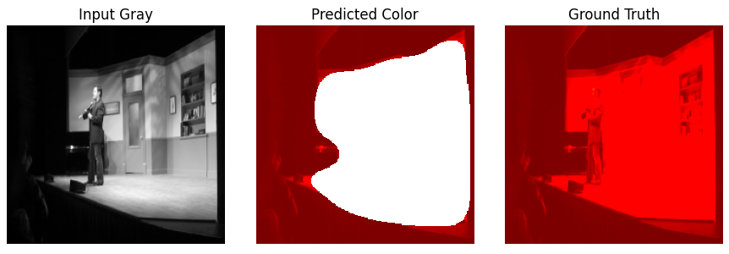
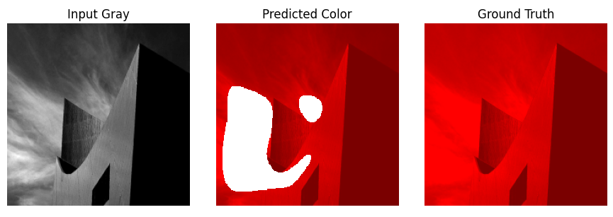
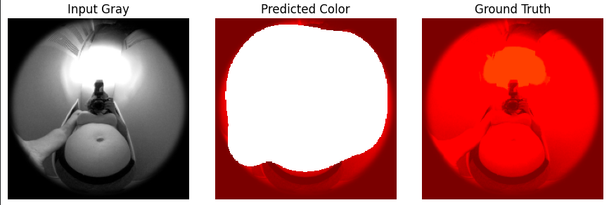

4.3.2 U NET Results:
The U-Net model generated more realistic and visually appealing colorized images.
- Input grayscale image
- U-Net colorized output
- Ground truth image
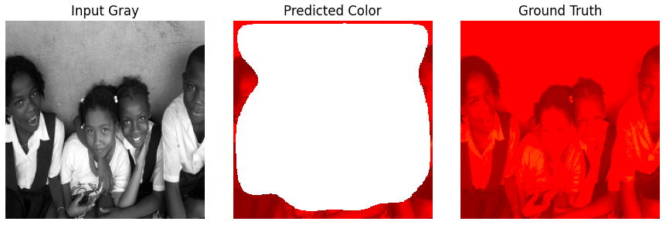
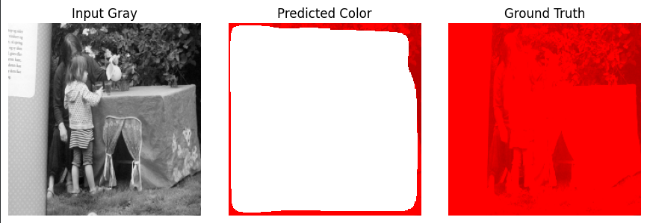
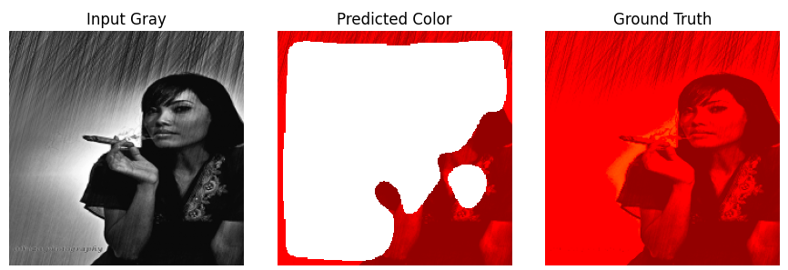

4.4 Model Comparison:
Feature | CNN | U NET
Color Quality | Low | High
Detail Preservation | Poor | Excellent
Training Stability | Medium | High
Visual Realism | Weak | Strong
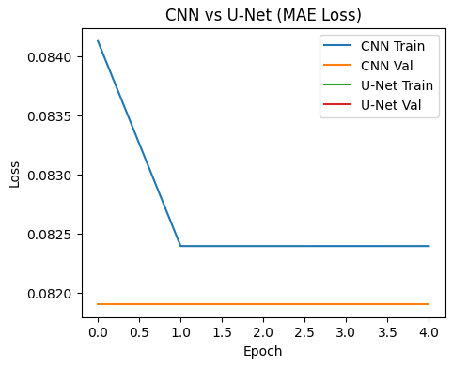
This project successfully implemented an AI-based image colorization system using deep learning. The CNN model served as a baseline, while the U-Net architecture significantly improved color quality and realism.Experimental results show that U-Net outperforms CNN due to its encoder–decoder structure and skip connections.

